# **D1 Evaluation and Justification**

## **Principles and Characteristics of Successful Enterprises**

There are several key principles and attributes that typically contribute to an enterprise achieving sustainable success. Creativity and innovation are vital characteristics, involving the ability to identify gaps in the market and develop new products or services to meet customer needs in novel ways. Successful entrepreneurs are adept at spotting opportunities where the market is not being fully served.

Technical expertise is also a core enterprise skill, both in terms of the entrepreneur's own knowledge as well as the capabilities of any employees or collaborators. For an IT business in particular, strong technical and programming abilities are essential to bring concepts to life and keep the business at the cutting edge of new developments in its industry.

Teamwork and collaborative working styles are likewise important principles. No individual can hope to possess all the skills required to launch and scale a company successfully. Strong partnerships and the ability to build a complementary and motivated team to share the workload are valuable characteristics.

Comprehensive planning is another hallmark of resilient enterprises. From well-defined business models and goals to contingency strategies, thoughtful preparation at the outset helps to mitigate risks and ensure the business can react effectively to challenges or opportunities that may arise. This includes considering competitive advantages such as unique selling propositions that will attract and retain customers.

Access to adequate financing is also a common factor for enterprises that achieve long term growth and impact. The ability to secure initial investment capital to develop products and services fully before commercial launch, as well as ongoing access to funding sources, supports scale and expansion goals.

Positive perception among potential clients and partners regarding the competence, vision and viability of the business further strengthens its position. Attributes of the entrepreneur such as charisma, passion and determination can aid this. Strong networking skills and an ability to gain advocates who actively promote the brand are valuable characteristics.

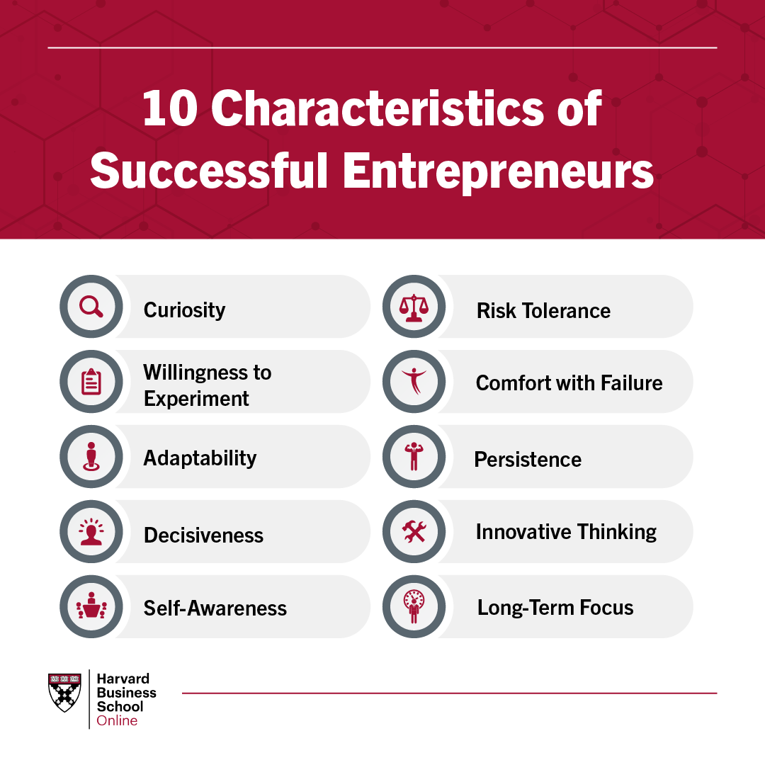

## **Example Analysis**

To demonstrate how these principles have been applied successfully in practice, this section will evaluate two established IT enterprises: Anthropic and OpenAI.

Anthropic is an AI safety startup founded in 2021 with a mission to develop beneficial artificial intelligence using a technique called Constitutional AI. This approach involves aligning language models with a "constitution" to ensure their behaviour remains helpful, harmless, and honest. Anthropic demonstrates several principles of success.

The company was founded by Dario Amodei, Daniela Amodei, Tom Brown, Chris Olah, Sam McCandlish, Jack Clarke and Jared Kaplan - a highly skilled team with strong technical expertise in the fields of machine learning and AI safety which has been integral to their progress. They also exhibit creativity through their innovative approach to Constitutional AI, identifying a gap in the market for AI alignment techniques.

Anthropic also demonstrates effective planning, having raised $130 million in funding rounds, and is led by a CEO, Dario Amodei, who is a research scientist at OpenAI and helps provide vision and credibility. Their work additionally fulfils a vital social purpose of developing powerful AI in a safe, trustworthy manner.

OpenAI is a non-profit AI lab working to promote and develop safe artificial general intelligence. Founded in 2015, it is backed by billions in funding from Microsoft and other major tech companies. OpenAI exhibits many principles of success including technical excellence, possessing some of the world's leading researchers in AI. They also demonstrate strong collaborative principles through partnerships.

OpenAI released GPT-3 in 2020, one of the most advanced language models ever built, exhibiting their capacity for groundbreaking innovation. They practice responsible research through techniques like Constitutional AI, and have secured major long-term funding - key factors in their ongoing impact and progress. Both Anthropic and OpenAI therefore serve as examples of how principles like skilled teams, creativity, planning and financing can enable successful AI enterprises.

## **Personal Skills Evaluation**

To gain an accurate understanding of my own entrepreneurial skills and expertise, I conducted a thorough self-audit of my competencies across technical, business, and personal domains.

On the technical side, I have over 5 years of experience in full-stack web development utilising skills such as Python, JavaScript, and SQL. I am proficient in technologies like machine learning and blockchain that are core to my business concept. However, my knowledge of cybersecurity best practices requires further development.

In terms of business and entrepreneurial abilities, I possess strong strategic thinking, communication, and networking skills cultivated over several leadership roles. I am self-motivated and solution-oriented. My experience analysing markets and presenting business cases to investors is also an asset. However, my financial modelling expertise could be improved.

On a personal level, I believe my passion, perseverance, and visionary tendencies will serve me well as an entrepreneur. I work well independently but recognise the value of collaboration. That said, my experience managing teams is limited due to my career stage.

Overall, while I have solid technical and business development foundations, some weaknesses were identified that could hinder startup success if not addressed. My cybersecurity and financial knowledge require bolstering. Developing stronger personnel management experience would also benefit me as the business scales. These gaps will need to be strategically overcome to fully realise my enterprise goals.

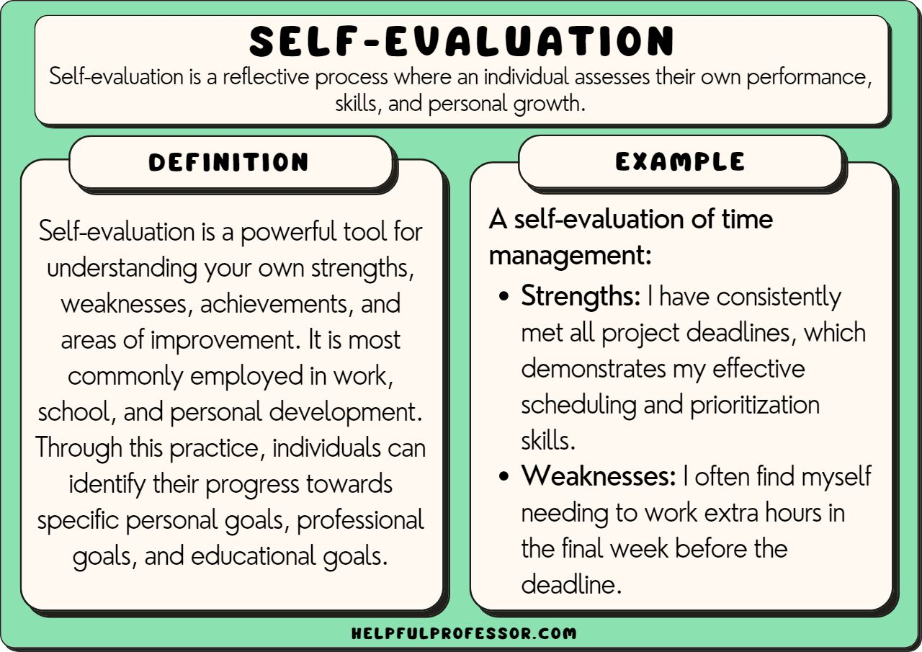

## **Strategies for Overcoming Gaps**

To effectively overcome the gaps and weaknesses identified in my skills audit, a multipronged approach will be undertaken.

For cybersecurity expertise, I plan to complete an online certification course from a reputable provider over the next six months. This will bolster my technical knowledge of best practices.

To strengthen financial modeling abilities, I will leverage available online tutorials and work through sample models provided by my local Small Business Development Center. Meeting with an accountant consultant initially will also help identify key metrics to track.

Expanding team leadership experience presents opportunities for growth. I will take on a supervisory role in my current job to practice personnel management. Additionally, I aim to join an entrepreneurial meetup group to network, learn from others, and potentially take on an advisory position to gain experience.

These targeted strategies address gaps individually through self-paced learning and hands-on experience. To complement this, leveraging the diverse skills of potential co-founders through a collaborative working style could help compensate for any weaknesses. Building a team with complementary expertise in areas like finance, security, and operations will enhance our collective capabilities.

With a commitment to lifelong learning and a willingness to utilise available resources, I am confident these approaches will allow me to successfully overcome limitations and equip myself with the robust skill set required for enterprise success. Regular re-evaluation will ensure continuous self-improvement.

# **M1 Discussion of Enterprise Principles**

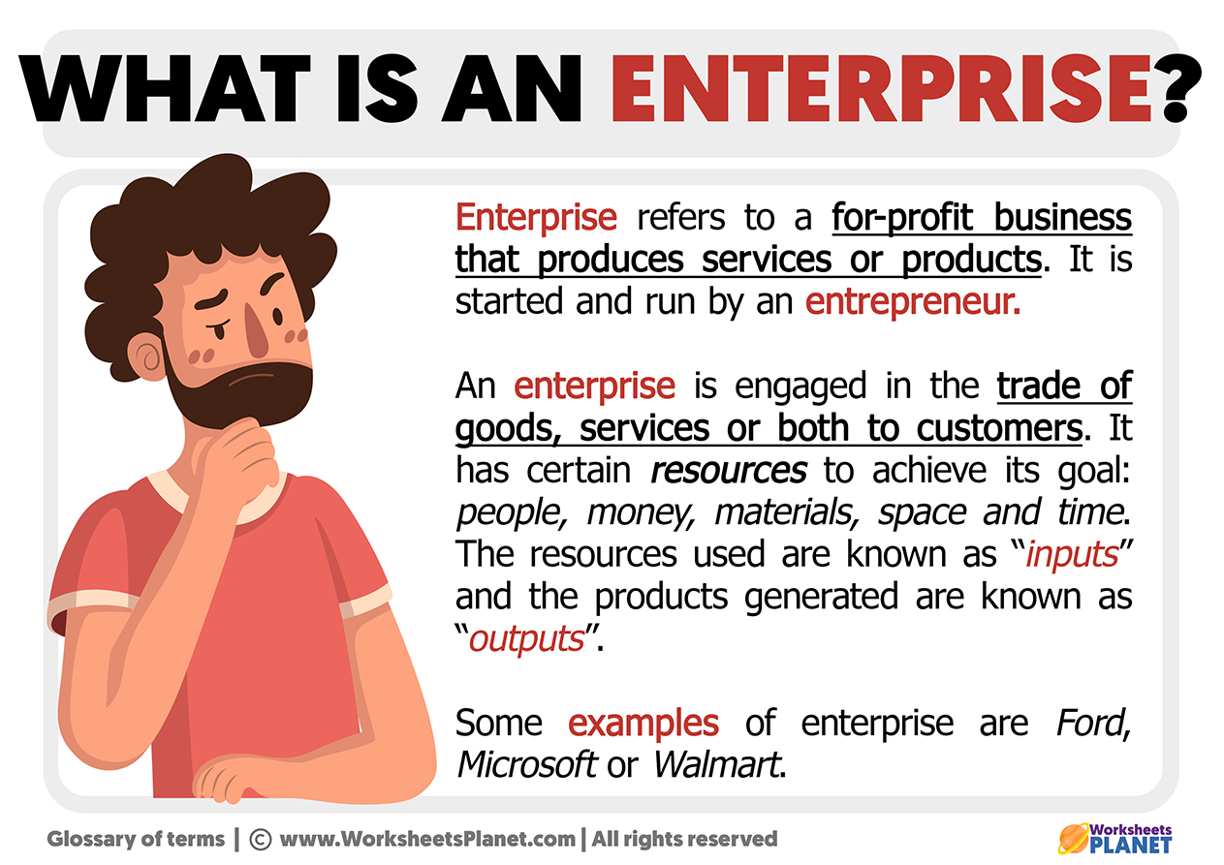

## **What is Enterprise?**

At its core, enterprise involves the creative process of identifying opportunities to meet customer needs in innovative ways through the formation of a business venture. It represents the act of harnessing one's skills, vision and work ethic to transform an idea or concept into a sustainable and impactful commercial reality.

Entrepreneurship is the mindset and approach that drives enterprise - it encompasses qualities like courage to pursue opportunities despite risks, perseverance to overcome challenges, and leadership in inspiring others towards a shared goal. Successful entrepreneurs exhibit passion, determination and problem-solving abilities that catalyse new products, services and economic activity.

A key facet of enterprise is recognising gaps in the market where current solutions are lacking and customer aspirations are not fully realised. The entrepreneur scrutinises these spaces to envision what could better serve users if delivered through their efforts. Creativity and innovation are thus at the heart of any new business, involving the fresh application of skills and technologies to fulfil unmet needs in original ways.

Enterprise also demands an efficient process of turning ideas into action. This requires marshalling resources through comprehensive planning and turning concepts into tangible offerings that create value for early customers. The results then fuel further growth, refinement and market penetration activities to establish the venture.

In summary, enterprise embodies an entrepreneur's skills, vision and perseverance in strategically satisfying customer needs through innovative, value-driven business-building - transforming opportunities into impactful commercial realities. These fundamentals form the basis of any successful enterprise.

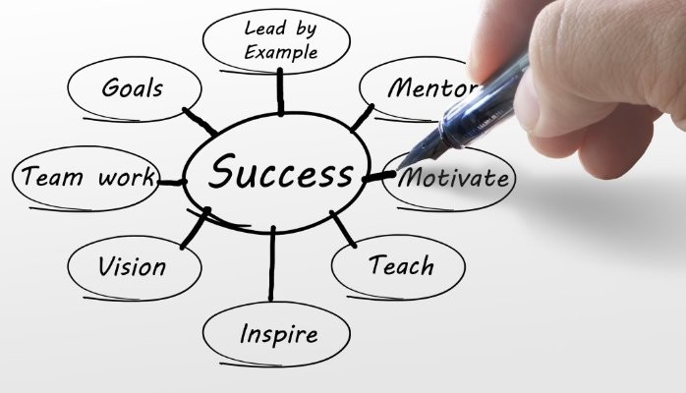

## **Characteristics of Success**

In observing many thriving businesses over time, some common traits seem to play an important role in their longevity and growth. Innovation is certainly a key factor - the ability to conceive novel solutions and recognise new opportunities sets successful enterprises apart.

Equally important is the talent and expertise within an organisation. Assembling a team with complementary skills and experience allows ideas to be transformed into reality. Collaboration then helps take concepts to the next level, ensuring all strengths are leveraged.

Comprehensive planning also lays the foundation for resilience. A clearly defined vision, supported by detailed strategies and contingency measures, prepares a business to weather changing conditions. Meeting customer needs is likewise crucial. Understanding markets and delivering value through superior offerings or service helps attract and retain clients.

Access to adequate resources also facilitates scaling. Whether it be funding to develop plans fully before launch or ongoing financing that enables expansion, capital availability supports growth goals. Presenting a credible image to potential partners and customers strengthens this position.

Qualities like determination, passion for one's work and a solution-driven mindset additionally benefit enterprises. These attributes help navigate challenges and drive continuous improvement. In summary, creativity, expertise, strategic preparation, client focus and access to resources have tended to promote sustainability and impact among businesses I've observed.

## **Example Analysis**

To demonstrate characteristics of success, it's useful to examine real enterprises that have achieved longevity and impact. Two such companies are Microsoft and SpaceX.

Microsoft was founded in 1975 and revolutionised personal computing through innovation. It created new technology categories with Windows and Office software. Today, it continues developing cutting-edge cloud, AI and gaming solutions. A skilled technical team has been integral, along with strategic planning - like acquiring emerging startups to maintain leadership.

SpaceX also epitomises creativity through achievements like reusable rockets. Founded in 2002, it has fulfilled founder Elon Musk's vision of low-cost space travel. Sufficient funding was secured to support ambitious goals, as were partnerships with NASA. Collaboration has been key - from international scientists to other corporations involved in joint ventures.

Both companies exemplify a solution-driven culture and passion that has allowed for disruption. They also meet customer needs through high-quality, convenient offerings. Resilience amid challenges stems from comprehensive preparation and expertise within diverse, talented workforces. Access to adequate financing at critical stages has underpinned growth plans. Their sustained success reflects an innovative spirit and strategic mindset cultivated since inception. These attributes continue to propel their work forward.

# **M2 Realistic Skills Audit**



## **Skills Audit**

To gain a clear picture of my current strengths and areas for development, I conducted a thorough self-evaluation of both hard and soft skills.

On the technical side, my programming expertise in Python, JavaScript and SQL provides a strong foundation for web and app development. Machine learning and blockchain experience also positions me well for the future of tech. However, deepening my knowledge of cybersecurity best practices through certification would strengthen my profile.

When assessing business and entrepreneurial acumen, I see strategic thinking, communication and networking as existing strengths. My past roles developing partnerships and presenting to investors demonstrate such abilities. However, financial modeling is an area I aim to sharpen by taking online courses.

Reflecting on interpersonal skills revealed perseverance, vision and passion for problem-solving. While I work diligently independently, expanding team leadership experience through a managerial role or advisory board position could boost my potential impact.

Overall, a blend of technical aptitude, business development expertise and strong personal traits have been identified. However, some gaps around cybersecurity, financial modeling and personnel management were also apparent. Addressing these through targeted self-study, hands-on projects and experience-building will create a more robust skillset aligned with my long-term goals. Continuous re-evaluation and commitment to lifelong learning will further support growth.

## **Identification of Gaps**

After conducting a thorough audit of my skills, here are a few gaps I've identified that could be strengthened:

Cybersecurity is an area with room for improvement. While I have a basic understanding of best practices, deepening my technical knowledge through certification would add value, especially as more businesses move online.

Financial modelling is another opportunity for growth. As planning and budgets are so important in business, sharpening my skills in this domain through online tutorials and working with advisors would serve me well long-term.

Team leadership is a soft skill I'd like to develop further. Taking on a supervisory role in my current work or joining a startup advisory board could help bolster my experience managing others and collaborating towards shared goals.

Additionally, while networking comes naturally, I recognise the need to continually expand my professional connections as an entrepreneur. Joining local industry groups and participating more actively would strengthen my support system.

Overall, targeted efforts addressing gaps in cybersecurity expertise, financial acumen, personnel management and industry networking can help enhance my abilities. With commitment to self-improvement and openness to learning from others, I'm confident these are areas I can make continued progress on.

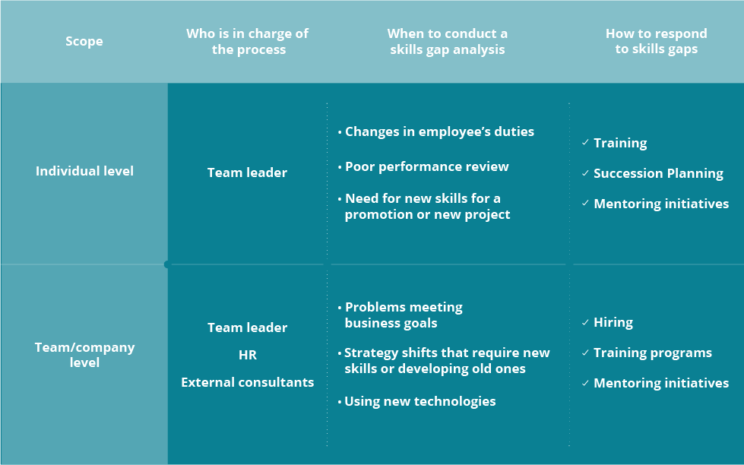

## **Proposed Strategies**

After conducting a skills audit and identifying some gaps, here are some proposed strategies for strengthening my abilities:

For cybersecurity expertise, I plan to take an online certification course through a reputable provider over the next 6 months. Obtaining this credential will boost my technical qualifications while helping clients feel assured of best practices.

To sharpen financial modelling skills, I'll use online tutorials to learn key techniques like forecasting, break-even analysis and ROI calculations. Applying these hands-on through mock projects or pro-bono client work will solidify the learning.

To gain team leadership experience, I'm reaching out to local startups about short-term advisory or project management roles where I can help coordinate workstreams. This will provide exposure managing personnel.

For networking, I'll join my city's tech meetup group and commit to attending 2-3 events per month to widen my circle. I'll also use these opportunities to stay updated on industry trends through speaker presentations.

By dedicating focused efforts to these strategies over the next six to twelve months, I'm confident my newly acquired qualifications and experience will close existing gaps. Continuous skill-building will also support achieving my long-term career and business goals.

# **References**

1. <https://www.personio.com/hr-lexicon/skills-audit/>
2. <https://www.bizcover.com.au/bizwitty/10-crucial-skills-need-start-online-business/>
3. <https://www.creativeteamevents.com/blog>
4. <https://able.ac/blog/characteristics-of-critical-thinking/>
5. <https://www.aihr.com/blog/skills-audit/>
6. <https://businessjargons.com/entrepreneurship.html>
7. <https://www.huffpost.com/entry/the-startup-skill-set_b_1224293>

# 